‘Promoted for and on behalf of Cycling Time Trials under their Rules and Regulations’

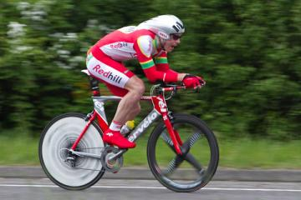
Redhill Cycling Club
18 mile “Sporting” Time Trial – GS/478
Sunday 25 February 2024 at 09.00
Event Secretary: Alison Steel
redhillcctt@gmail.com
Headquarters: St John’s Hall
Furlong Road
Wescott, RH4 3PP
It was not a great morning for cycling, cold and a lot of standing water, so well done to all the riders who completed this course.
Grateful thanks to:
Timekeepers Mick Irons at the start and Richard Meed at the finish
Start assistant Simon Andrews
Marshals and Checkers Bruce Dunbar Roger Hopkins Kevin Jones Dave Elliot Chris Hall Martin Guare
Jacquie Phillips Steve Bryant Birgit Clark
Paul Banfill Bryan Strapp Francis Jordan
Peter Farnfield Jim Tagg
Broom wagon David Gill
Finish Spotters Janina Wightman Clive Lucy
HQ signers in/out Norman Phillips Frank Grainger Siobhan Delaney
Rick Gregory

Photographs were taken by Paul Carpenter: Paulcarpenterphotography1992@hotmail.com. If you would like a copy of your photo, please send him a description of your bike and kit. Please see flyer below.

